Lesther John B. Erocido BSIT-4A

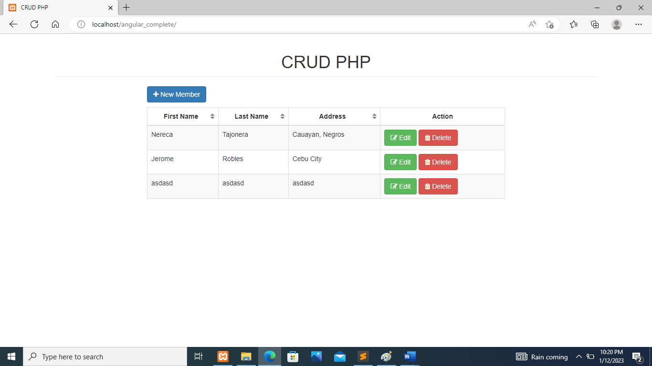

This is the landing Page of the system, a simple crud operation, for inputing Personal Information.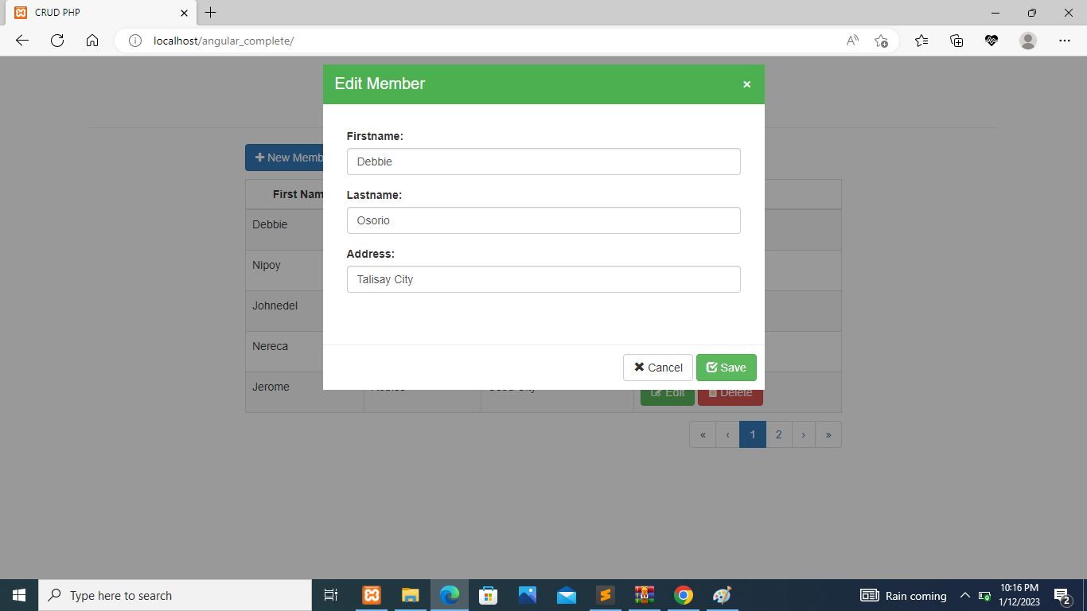

This is the edit form window if you click the edit buton.

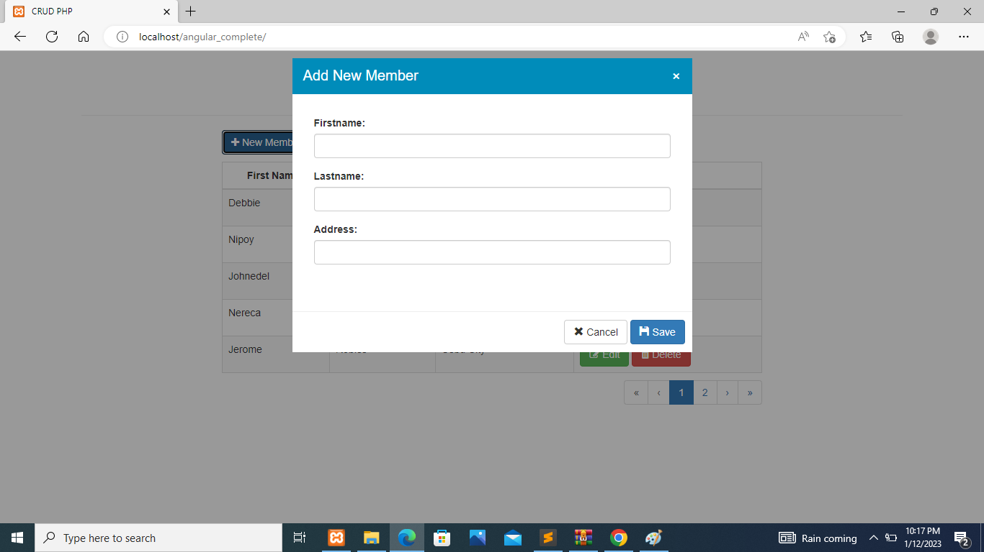

You will see the add new member form when you click the new member button.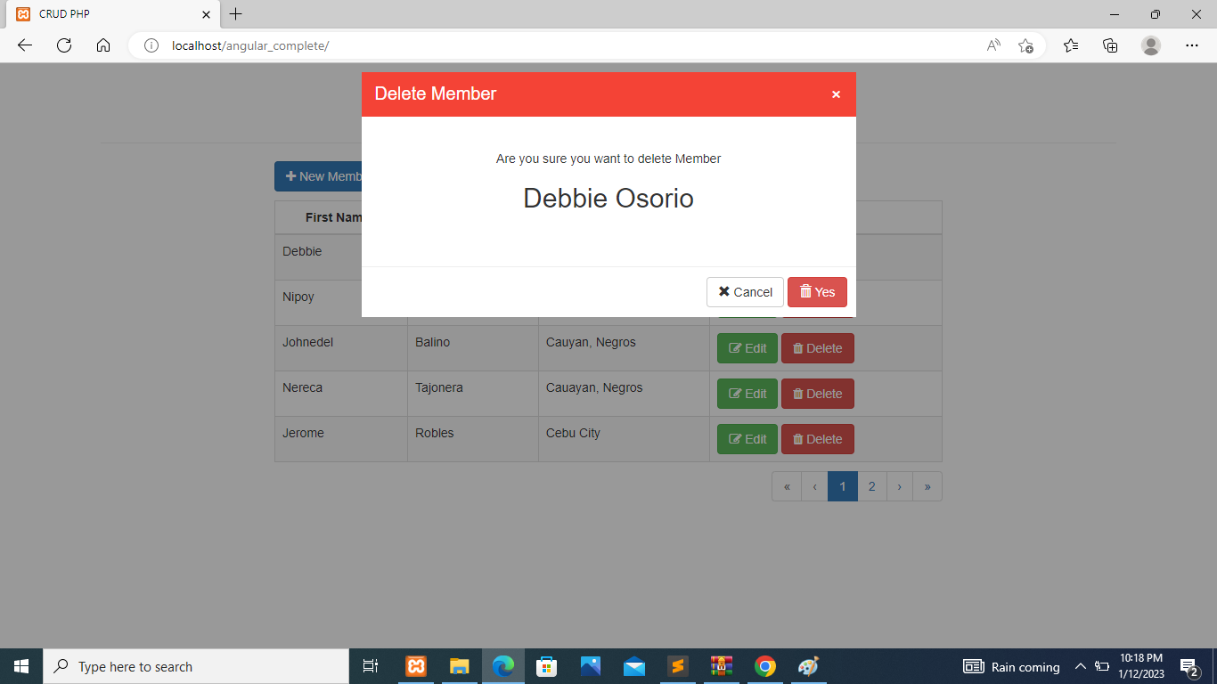

This is the delete window when you want to delete a user